

*shell programming lab*

aSsignment -17

**SUBMITTED BY: SUBMITTED TO:**

**AYUSH KUMAR JHA Dr. Dhiviya Rose**

**SAP ID - 500086400**

**Enrollment no - R200220083**

**B.C.A -I.O.T.**

EXPERIMENT – 17 & 18 in Manual

TITLE: System and Memory Administration

Activities:

1. Monitor the memory Usage

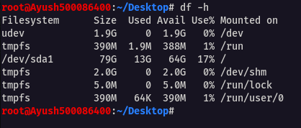

1. Monitor the free space

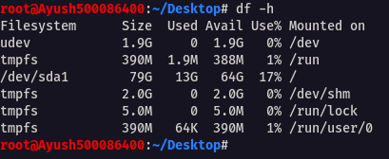

1. Monitor the speed

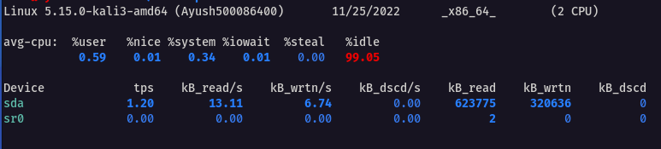



4.Starting Up the system



5.Shutting the system down

